Random Forest -> fitControl.rf <- trainControl(method = "repeatedcv",

number = 2,

repeats = 2)



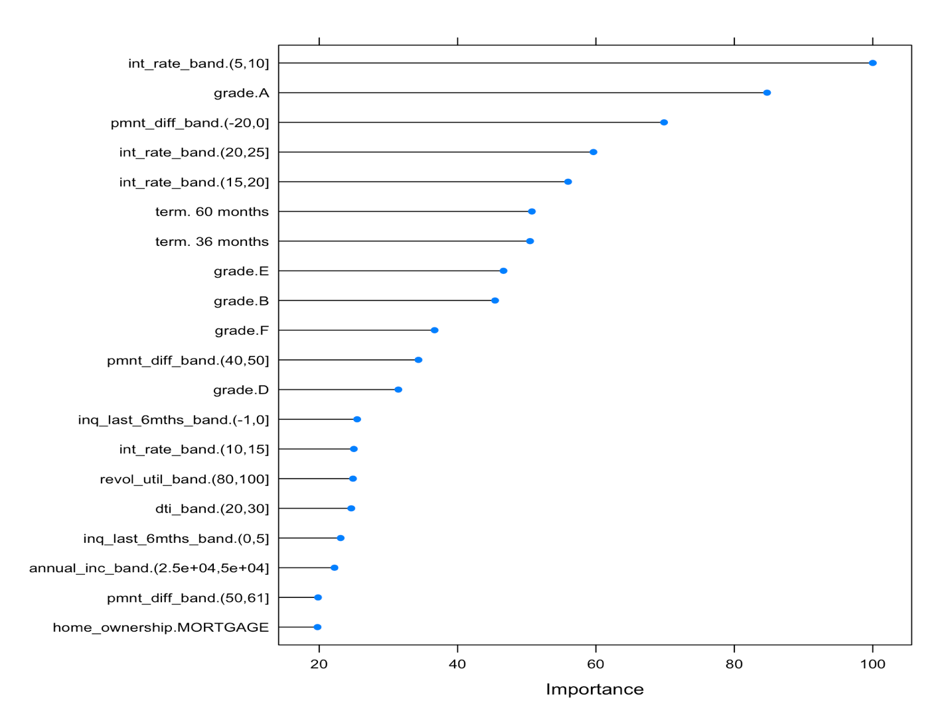

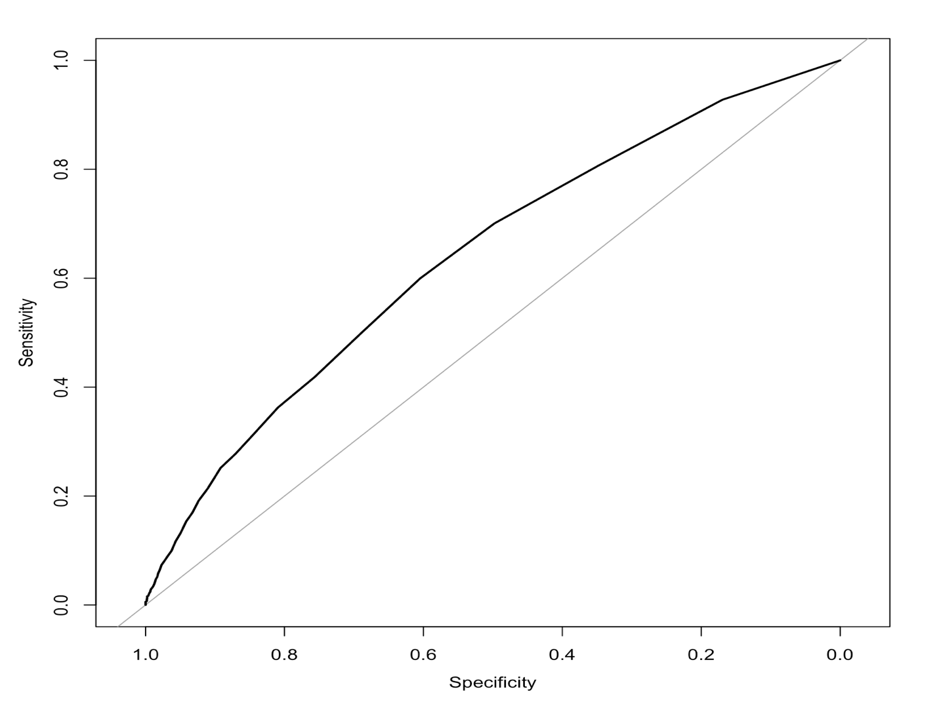

GBM -> fitControl.gbm <- trainControl(method = "repeatedcv",

number = 10,

repeats = 4)



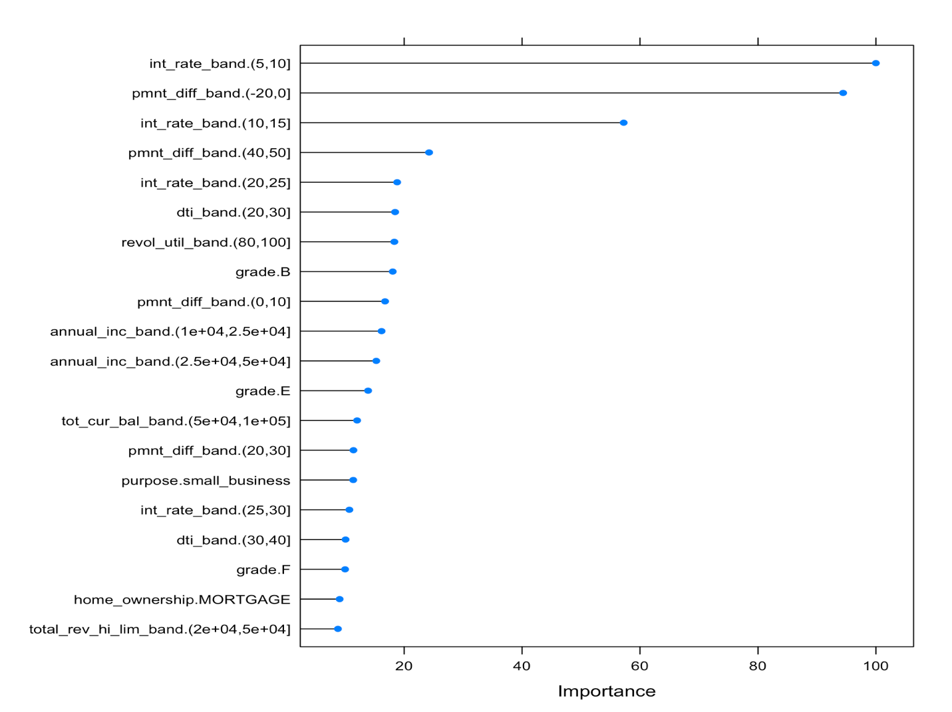

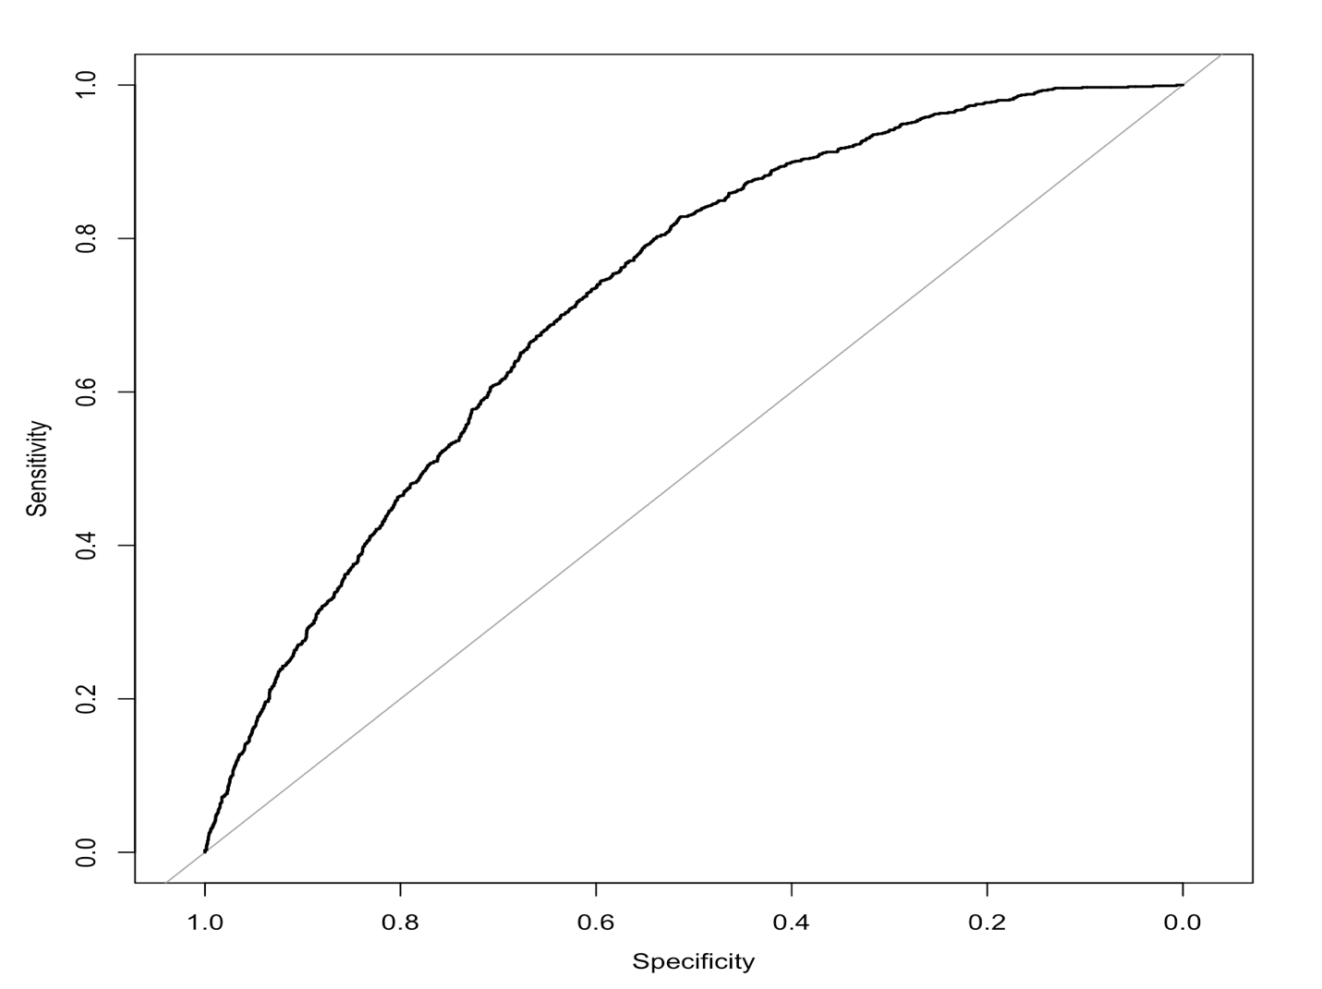

GBM -> fitControl.gbm2 <- trainControl(method = "repeatedcv",

number = 10,

repeats = 4,

sampling = "up")



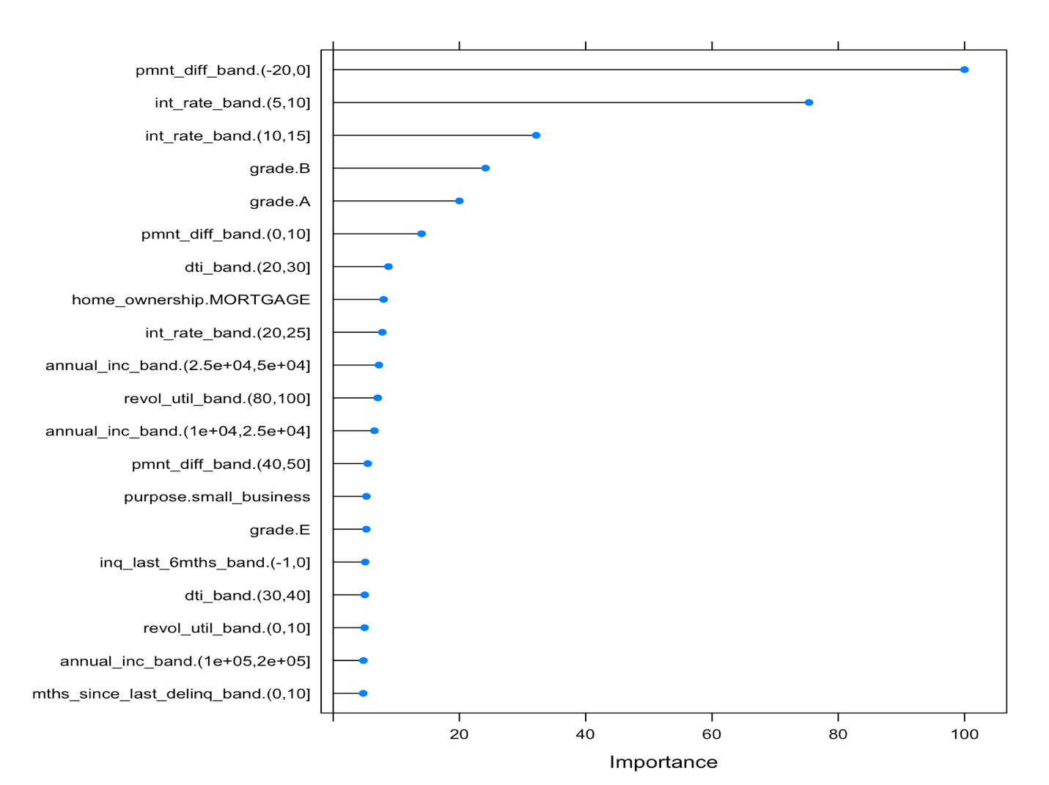

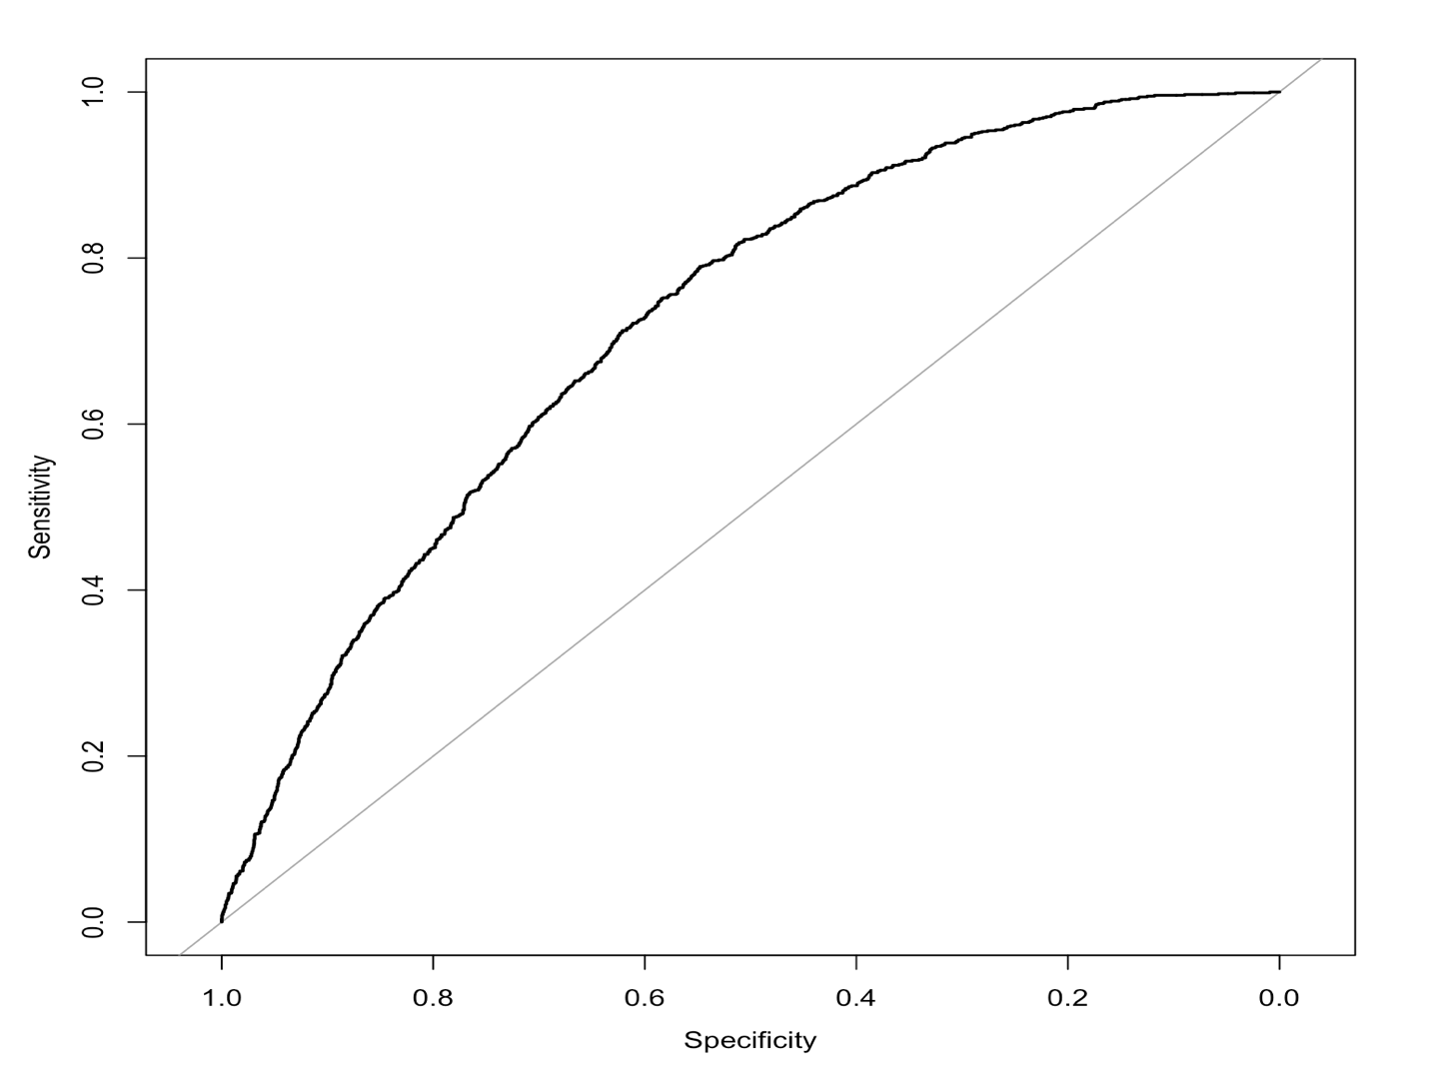

GBM -> fitControl.gbm3 <- trainControl(method = "cv",

number = 10)



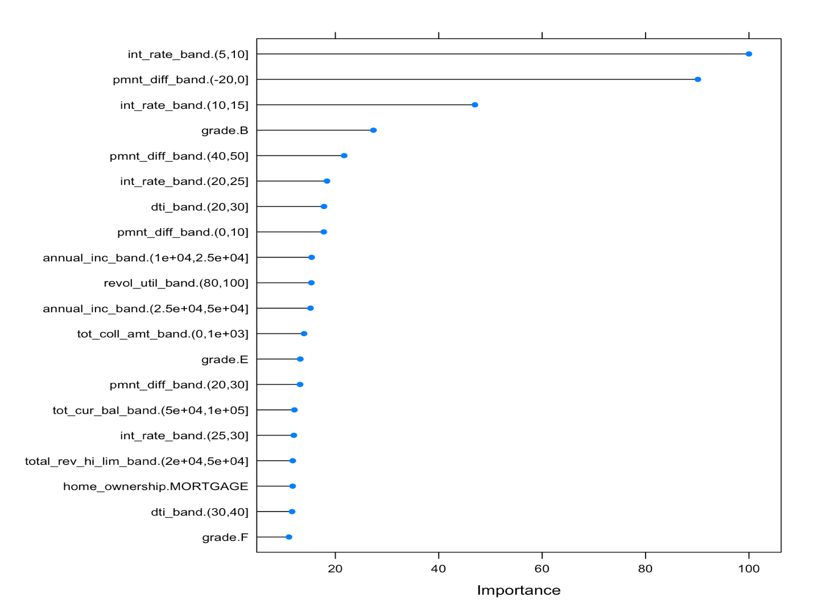

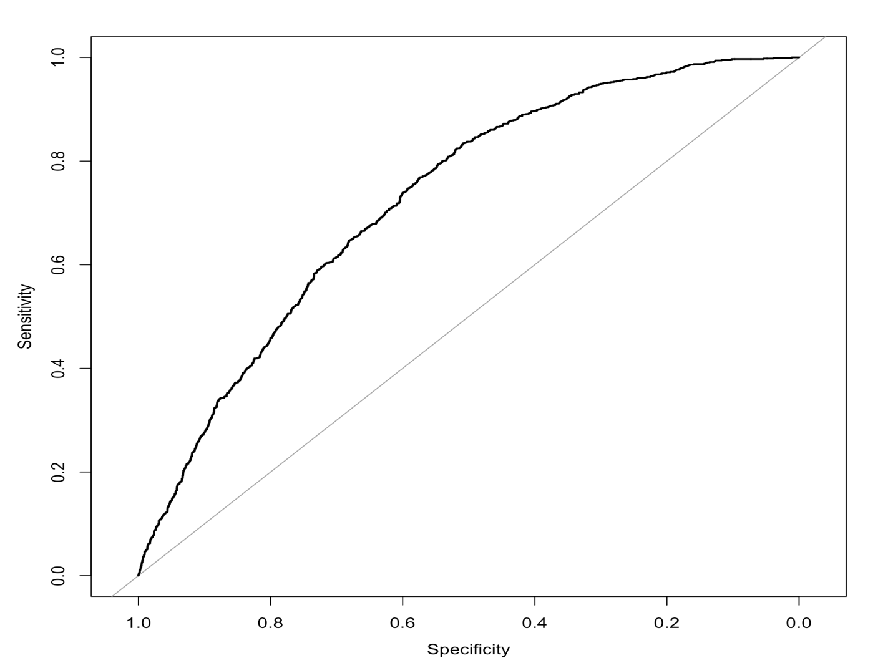

GBM -> fitControl.gbm4 <- trainControl(method = "repeatedcv",

number = 10,

repeats = 4,

sampling = "down")



